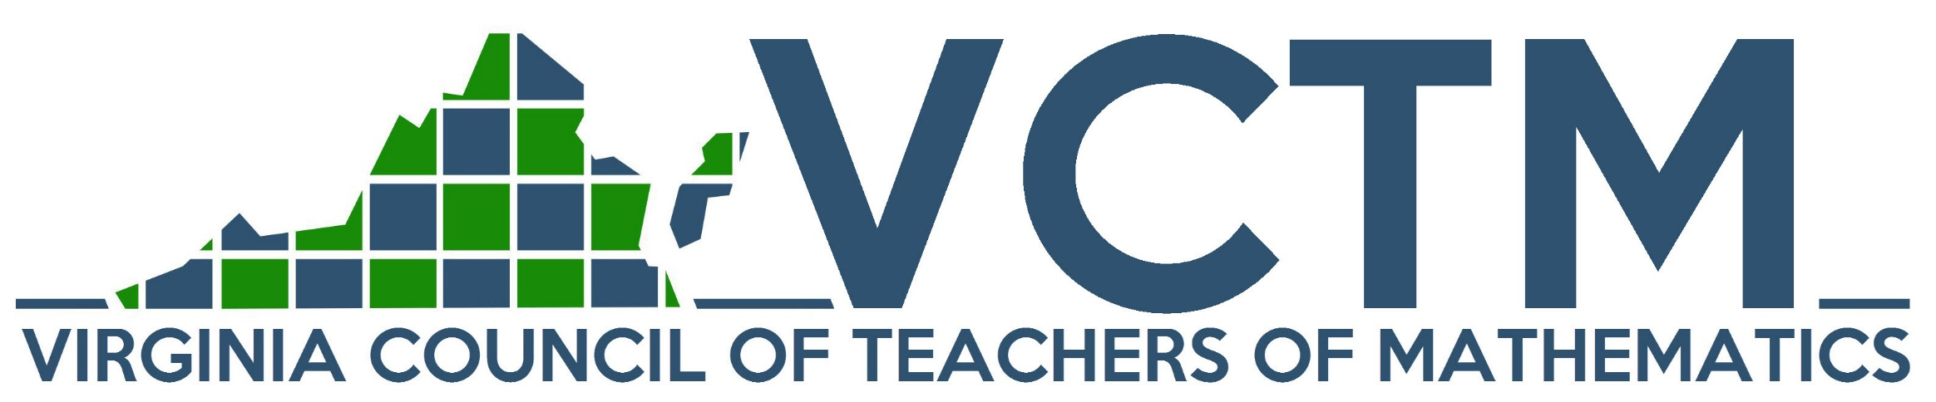
VCTM PROFESSIONAL DEVELOPMENT
GRANT PROGRAM
The VCTM Professional Development Grant Program is a one-time grant opportunity of up to $1000 for two recipients who are members of VCTM. The purpose of this program is to provide funding support to VCTM members who wish to attend workshops, institutes, or other in-service opportunities to learn more about mathematics teaching and learning. The funding for this grant can be used for registration, room and board, and transportation expenses. This program will not fund undergraduate or graduate courses or attendance at VCTM or NCTM conferences. The application requires that applicants attach a short explanation of why the applicant wishes to attend the professional development opportunity and how it will benefit the applicant’s classroom. If the professional development is non-traditional then the applicant must detail the learning experiences in the section of why they wish to attend. Applicants should submit a copy of the workshop, institute or in-service announcement. In addition, applicants should submit a specific budget request. If awarded, the applicant will share their knowledge with the VCTM membership by writing an article for the Virginia Mathematics Teacher and/or presenting at the VCTM annual conference.
Applications are due on February 1, 2017 and notification will be made by March 1, 2017. Funding will be reimbursed after the awardee has attended the event and submitted receipts to the treasurer of VCTM.

CURRENT VCTM MEMBERS ARE INVITED TO APPLY FOR THE VCTM PROFESSIONAL DEVELOPMENT GRANT
This grant is available for registration, room and board, and transportation expenses.
Two grants of up to $1000 will be awarded.
The grant is a one-time honor.

Name: | Home Phone:
Home Address: | Email Address:
VCTM Member #: | Fax:
School: | School Phone:
School Administrator/Director: | Admin. Email Address:
School Address:

Present teaching/working assignment:
Name of Workshop, In-Service, or Institute:

Local Newspaper and Address:

___________________________________________________________________________________________
Please attach the following to the application:
- a copy of the program announcement;
- a budget itemizing specific costs and the total amount requested;
- a short explanation of why the applicant wishes to attend the workshop, institute or in-service opportunity and how it will benefit the applicant’s classroom.

PROFESSIONAL DEVELOPMENT GRANT RUBRIC

Professional Development is defined as
- “…the pursuit of knowledge that helps students, teachers and other professionals achieve career advancement or enhance their personal effectiveness at school or work” (http://learn.org/articles/What_is_Professional_Development.html).
- “…learning to earn or maintain professional credentials such as academic degrees to formal coursework, conferences and informal learning opportunities situated in practice. It has been described as intensive and collaborative, ideally incorporating an evaluative stage” (https://en.wikipedia.org/wiki/Professional_development).
This grant does not cover formal coursework, VCTM or NCTM conferences.
Informal professional development must detail the educational experiences whether it is mathematical or pedagogical.

Criteria | Points
VCTM Member (#_________________)
Narrative explaining why the applicant wishes to attend the professional development. If the professional development is non-traditional, then the learning experiences must be detailed. | /10
Narrative explaining how the professional development will benefit the applicant’s classroom. | /10
Copy of the announcement advertising the professional development. | /5
Budget detailing ALL expenses. Sample categories might include registration cost, travel expenses, lodging, and materials/supplies. | /15
TOTAL | /40

In addition to the above, rank all applicants in order of priority of receiving the award with #1 as the top submission. (This is important especially in the case of ties.)
Priority Ranking ___________________

If awarded, the applicant will share their knowledge with the VCTM membership by writing an article for the Virginia Mathematics Teacher and/or presenting at the VCTM annual conference.
Funding will be reimbursed after the awardee has attended the event and submitted receipts to the treasurer of VCTM.

Submit application to:
Pam Bailey (804) 282-9164 Office
Assistant Professor, Education (540) 735-5372 Cell
Mary Baldwin University prbailey@marybaldwin.edu
Richmond Regional Center
2810 N. Parham Rd., Suite 303
Richmond, VA 23294

